1. In Admin : In advertisement when you want to change the status of the advertisement, here is the error message that appears see the capture below.

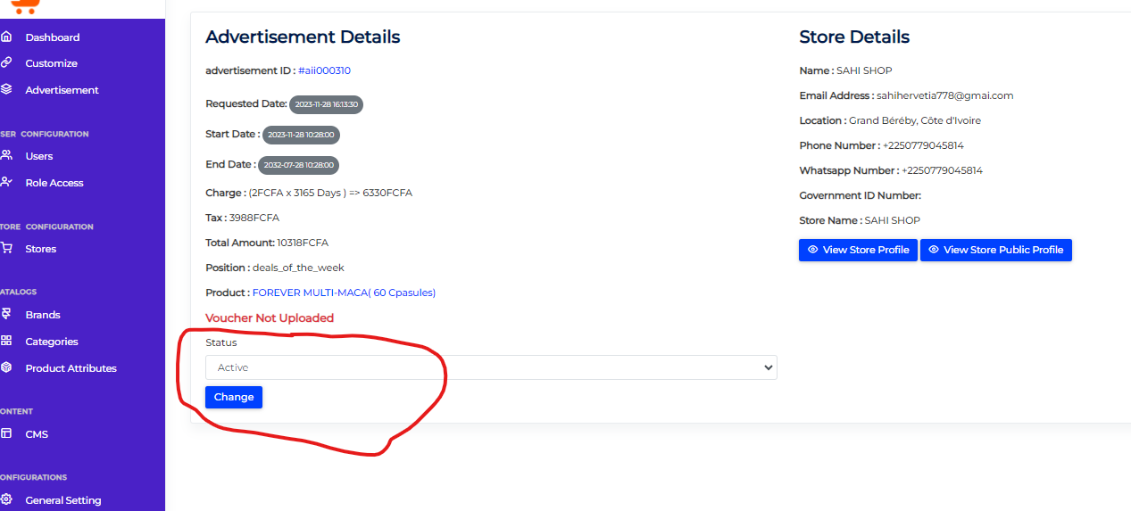

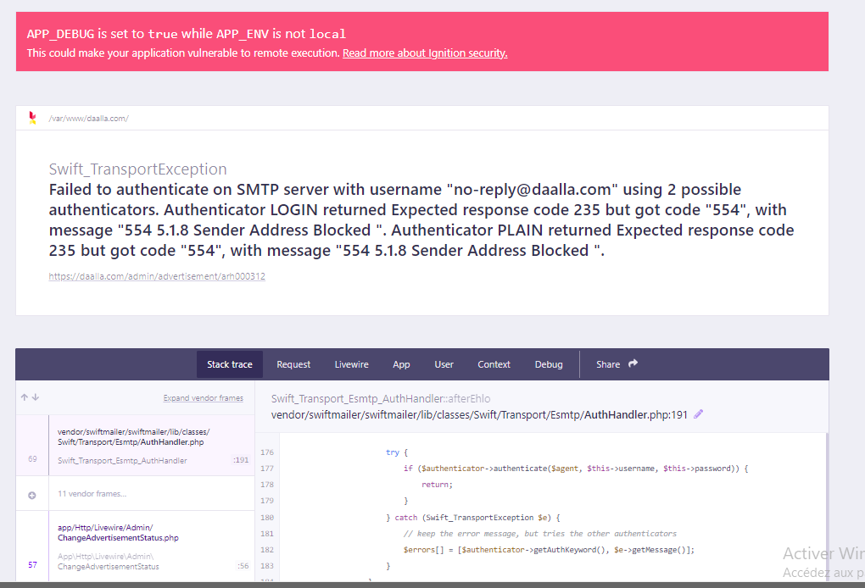

2. In store : in DAALLA PUBLICITE, after having completed the part that I circled in red and click on the ''Save'' button. Here is the error message displayed in the screenshot below.

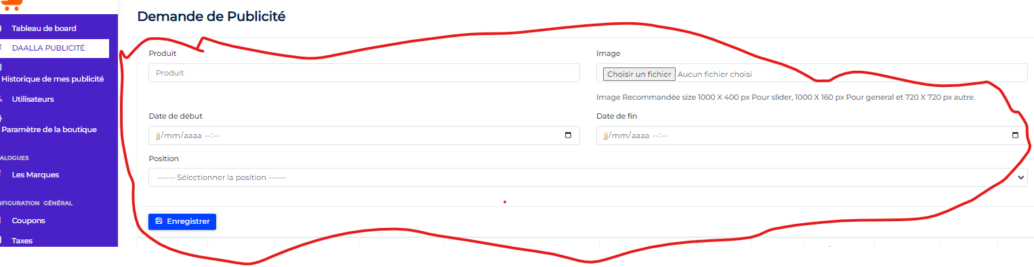

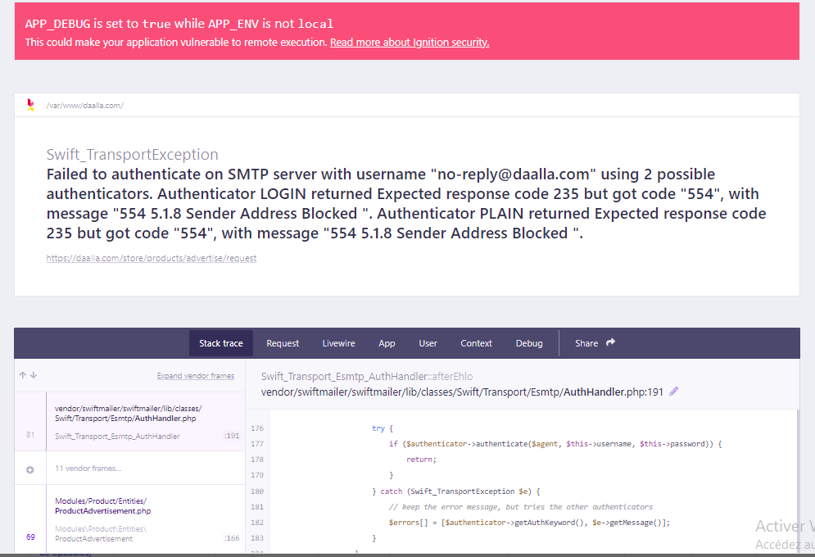

3. After following the order process and clicking on the ''Continue'' button to finalize the order, here is the error message displayed below.

